Walk 48 Bredwardine
Last walked in January 2017

Description. An 8 km (4.8 mile) strenuous hilly walk along fields, lanes and roads. Beautiful views across the Wye Valley.Wye Valley, lanes, fields and views.
Start. Bredwardine Church. Explorer Map 201 Grid 335445.
Directions from Whitecross Roundabout (Turn milometer to zero). Take the A438 Brecon road and after 9.1 miles TL towards Bredwardine. After another 1.6 miles [10.7m], just before the T-junction in Bredwardine, TL to Bredwardine Church. Park at the side of the road just before the church.

1. Bredwardine Church. St Andrew's Bredwardine is a fascinating church of considerable antiquity. The south doorway and much of the nave date from the time of the Conquest, and the chancel was rebuilt after being partially destroyed by Owain Glyndwr's soldiers in 1406. Inside, notable features include a massive font, and the tombs of a gigantic knight, Walter Baskerville and a smaller effigy of Sir Roger Vaughan who died defending Henry V at the Battle of Agincourt in 1415. Facing the church, TR onto enclosed public bridleway, after a short distance you go thru a gate, and then TR down an enclosed sunken track. Continue along the track, (ignore any tracks forking off L or R), and go thru a metal gate, then continue on to cross over a boardwalk, which is to the R of a small lake and swampy area. Continue in the same direction. Go thru a gap to the L of the next stile and across a small stream into an open field {F1}. Fork L and follow the L edge of the field to the far L corner where you cross a stile into {F2}. Continue up and along the L edge of this large field and at the top L hand corner you cross a stile/gateway to continue along an enclosed grassy track. Just before the track bends sharp R and joins onto another track, you continue in same direction to cross over a stile/metal gate into {F3}. Continue in the same direction keeping to a hedge on your R, and after about 80m you TR over a stile into {F4}. Head for the top L of this field to go thu a gate onto a road, opposite Moccas Park.

2. Minor Road. TR and walk along a not unpleasant minor road for about ½ km. A short distance past Lawn Gate Cottage, the first house on your L, you TL and proceed up a narrow road and thru a gate to reach Bodcott Farm. At the end of the barn and opposite the farmhouse you TR and go thru a metal gate. In front of you are three metal gates, take the R hand gate and follow the finger post into {F5}. Head directly across to the marker post in front of you, then keep to the fence on your R to reach the corner, where you cross over a stream and then a stile into {F6}. TL, after 50 metres you cross over an awkward stile into {F7}. Head diagonally R to go up to cross a stile on the steep grassy bank and into {F8}. Bear slightly L and walk up the field to cross a stile/metal gate onto a road.

3. Odhouse Lane. Cross the road and walk along a tree-lined enclosed lane, ignore the drive to The Hollies on the L and continue along the lane to pass over a cattle grid and reach a metal gate that is just to the R of The Old House Farm. Go thru the gate into {F9} and TL, 30m on you TR, (ignore any way mark signs pointing off to the L) and follow the fence on your R. Continue on around the R edge of the field to top where you TR thru a wooden bridle gate into {F10}. Continue along the R field edge and when reaching the corner you go thru a metal gate and down an enclosed farm track to reach a narrow road by Cherry Orchard Cottage. TL and walk along the narrow road and after a short distance, as the road bends to the R, you TL to follow a bridleway that is to the L of Pystil Gwynne Cottage. Continue on thru a gateway and then on thru a small metal gate at the end of the garden/field into {F11}. Continue along the R field edge, keeping the gully on your R, to go thru a metal gate into {F12}. Continue in the same direction and go thru another metal gate into {F13}. Continue in the same direction, to eventually cross over the stream and gully, the gully is now just a ditch and the stream is down to a trickle. Go thru a small wooden gate opposite ‘Holly Bush Cottage’, TR along a short drive to reach the road.

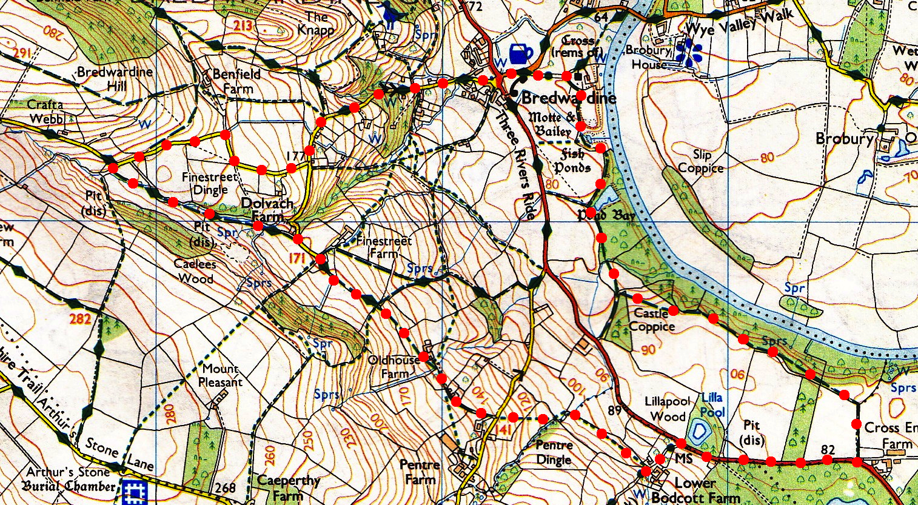
4. Road. TR, go along the road, which bends R and further on it bends L as it passes a road on the R called Fine Street. Continue on down to the bottom of the 1 in 4 minor road to reach the cross roads by the Red Lion Hotel. Go straight across, pass the war memorial on your L and a little further on you TR along the lane to Bredwardine Church.
1
2
3
4

